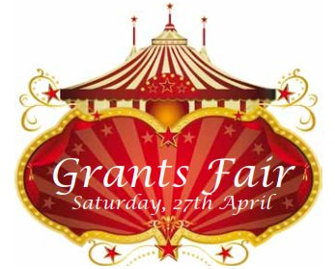

Saturday 7th March 2020 - Swan Hotel, 19 The Thoroughfare, Harleston IP20 9AS
9.00am start - £5/head – includes bacon roll & coffee

It’s that time of the year again and this is the opportunity for your Club to promote any projects that you wish to undertake. By “selling” your schemes and attracting funding from other Clubs and the New Grant system, you will be able to build larger projects for your local and international communities.
Conversely, if your Club has a surplus of funds in your charity account, you will be able to help support other Clubs’ projects. That’s not a silly as it may seem, as even small sums can add up – especially when either of the grant matches are taken into consideration. The Grants Fair is open to all members of your Club, although it would be good to have your President-Elect and any member ready to make grant applications.
This is also the chance for you to invite your friends from corporate organisations, and for them to see how Rotarians support communities in need. By giving their financial support to your projects, it would be their opportunity to be associated with an organisation that will one day have been responsible for the eradication of polio. Increasingly, businesses want to be involved in Corporate Social Responsibility programmes that point to how their company has made a difference to social problems.

The cost of the event including breakfast will be £5 per head, and cheques should be made out to “RI District 1080” and forwarded to the following address:

John Beer: D1080 Foundation Grants Sub Committee Chair
168A Lynn Road, Downham Market, Norfolk. PE389G
Telephone: 07899756021
john.beer@kbocic.co.uk

PAYMENT WILL NOT BE ACCEPTED ON THE DAY

Name | Club | Dietary Requirements

